A quick docker-compose project

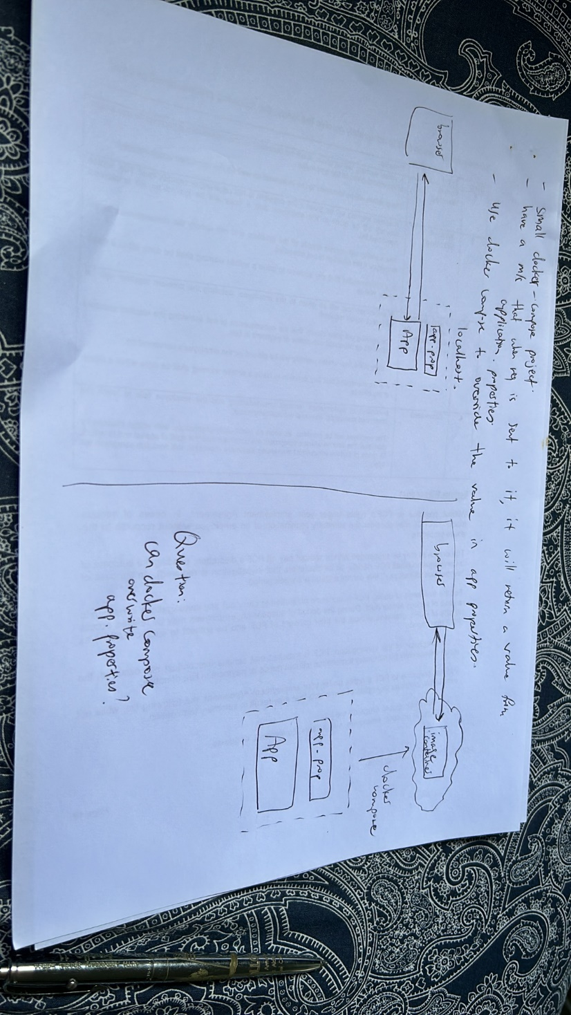

1. First, try to run the project on eclipse and send a request to it .. it’s a rest API
2. Then try to retrieve a value from the application.properties
3. Then, use docker-compose to now deploy the app to “the cloud” (?)
4. Use docker-compose.yml to change the application.properties
5. See if the return value changes accordingly or not

First, created a new spring boot project

This spring boot project will be in my github

Its called demo-porject-1

It has a rest api endpoint that basically returns a value that is taken from application.properties

Its pom.xml contains a build plugin that allows an image to be created from it to be put into docker desktop

1st: running on eclipse as spring boot app

The correct value from application.properties is indeed retrieved

Now, need to proceed to do the following things

1. Kill the server in eclipse
2. Create an image of the project in dockerhub
3. Use docker compose up to containerize it
4. In docker-compose.yml, override the application.property value

Right click on the project, run as maven build

spring-boot:build-image -DskipTests

this will create an image in docker desktop

Now image is created, but it has to be containerized to allow it to “accept” requests

We will use docker-compose.yml to containerize it

Now can shoot requests to localhost:8080/sampo already

What value will we expect?

This is the value returned, which is the value in application.properties

Why is it not overridden?

Coz in the .yml file, the env variable name is wrong!

This should do it

Delete the current container

Run docker-compose up again

Hit the url again

